Dear Mr.Yasuhiko Sata
Sata Foundation 1.May 2010

We really appreciate your constantly kind donations to Ban Rom Sai.
Since the middle of March, the children of Ban Rom Sai are in the summer vacation so they have enjoyed reading books in the library, playing football and badminton, going to the river and so on.
Thanks to your great support we have been able to carry out many projects with our children and the inhabitants in this village.
For instance, we are going on a camping trip to Doi Inthanon National Park. From our activities with the children and engagement with the local community we have seen prejudice and exclusion of HIV/AIDS infected people steady decrease. We really hope that the situation for our children will continue to improve and that our society would be changed to be better for all of us, where has not any prejudice and exclusion.

Please continue to observe the growth of our children. Our work and the lives of the children depend on donors like you and we would be grateful if you continue supporting them and our home.

Thank you again for your generosity.
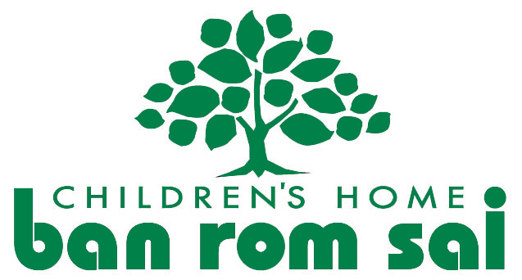
Sincerely yours,
Miwa Natori
Ban Rom Sai

