Statue of Virgin Mary damaged in Nagasaki A-bomb attack heading to New York
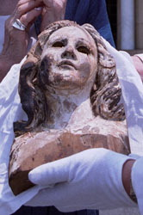
The head of the A-bombed statue of the Virgin Mary is pictured in Nagasaki in this 2005 file photo. (Mainichi)
NAGASAKI -- A statue of the Virgin Mary that was damaged by the atomic bombing of Nagasaki will be sent to Europe and the United States ahead of its display in New York in line with the review conference on the Treaty on the Non-Proliferation of Nuclear Weapons (NPT) next month.
The head of the statue, which was found in the rubble of the former Urakami Cathedral in Nagasaki after it was devastated by the atomic bombing on Aug. 9, 1945, left the city on Monday. The statue was to arrive in Tokyo before flying to Rome on Tuesday.
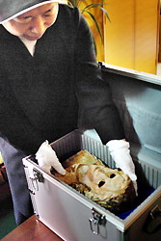
The head of the A-bombed statue of the Virgin Mary is carefully placed in a duralumin case at Urakami Cathedral in Nagasaki on Monday. (Mainichi)
The statue is scheduled to arrive at the Spanish city of Guernica, a city that suffered the first indiscriminate bombardment in human history, for display on April 26, ahead of an exhibit in New York on May 2 in line with the NPT review conference.
Shigemi Fukahori, 79, a Christian who survived the A-bombing of Nagasaki and is traveling to Europe along with the statue, said, "The statue was truly beautiful before it was damaged by the bomb. It shows the absurdity of war."
(Mainichi Japan) April 20, 2010

